

# Test Automation

**Experiment 3**

**Scrapy scrape quotes**

**Submitted by : Submitted to :**

**Akhand Pratap Singh Mr. Alind**

**Step 1**: Activate environment:



**Step 2**: Create a project

Command :- scrapy startproject project_name

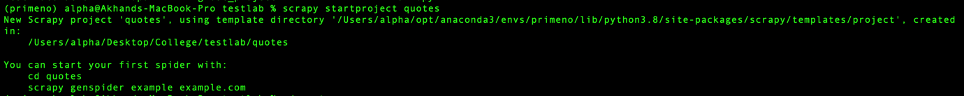

**Step 3**: Create python file named quotes_spider.py in

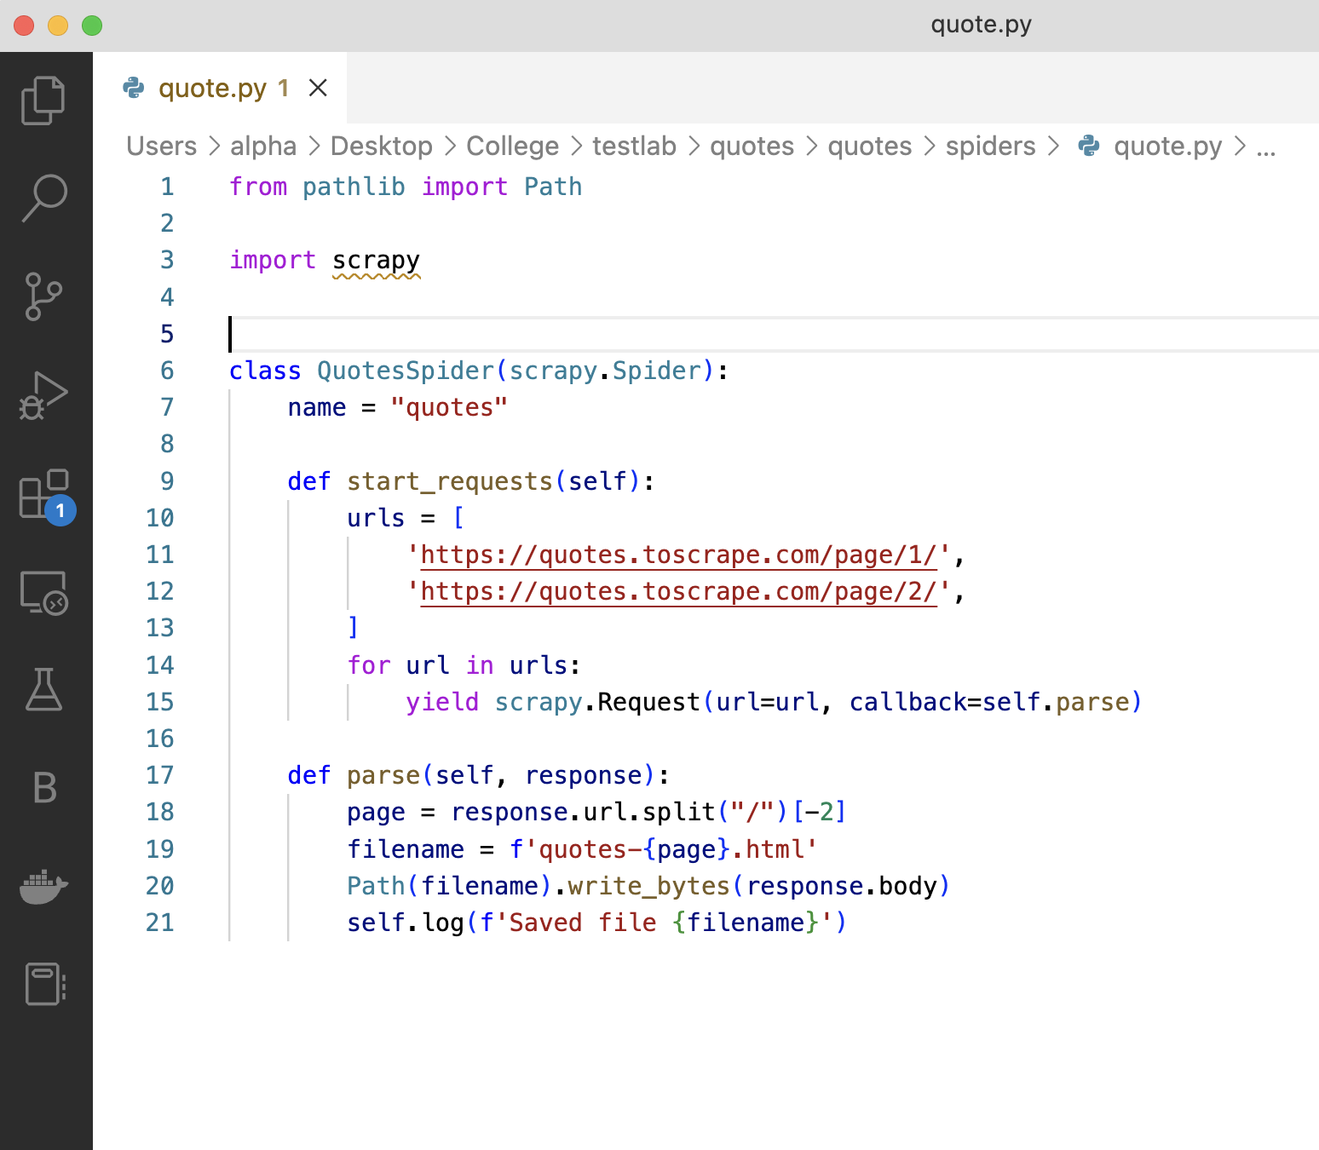

**Step 3**: Run the script

